* Install Power BI Desktop and share the final screenshot of the report view page which appears when power desktop starts.

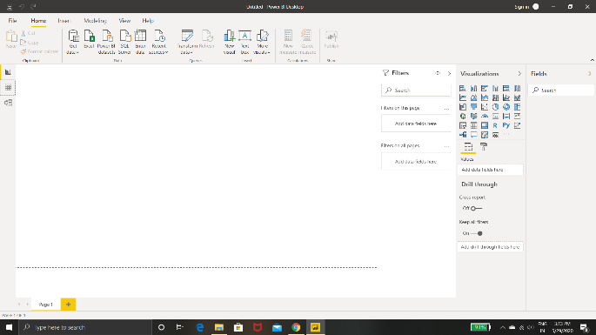

* Prepare a document and with the following screenshot −Report View.

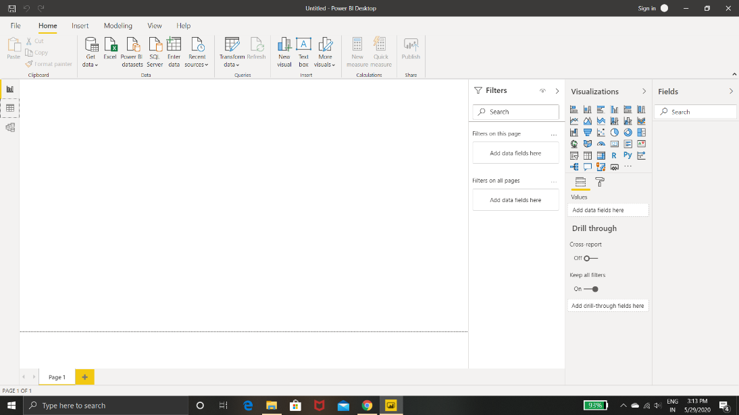

* Data View

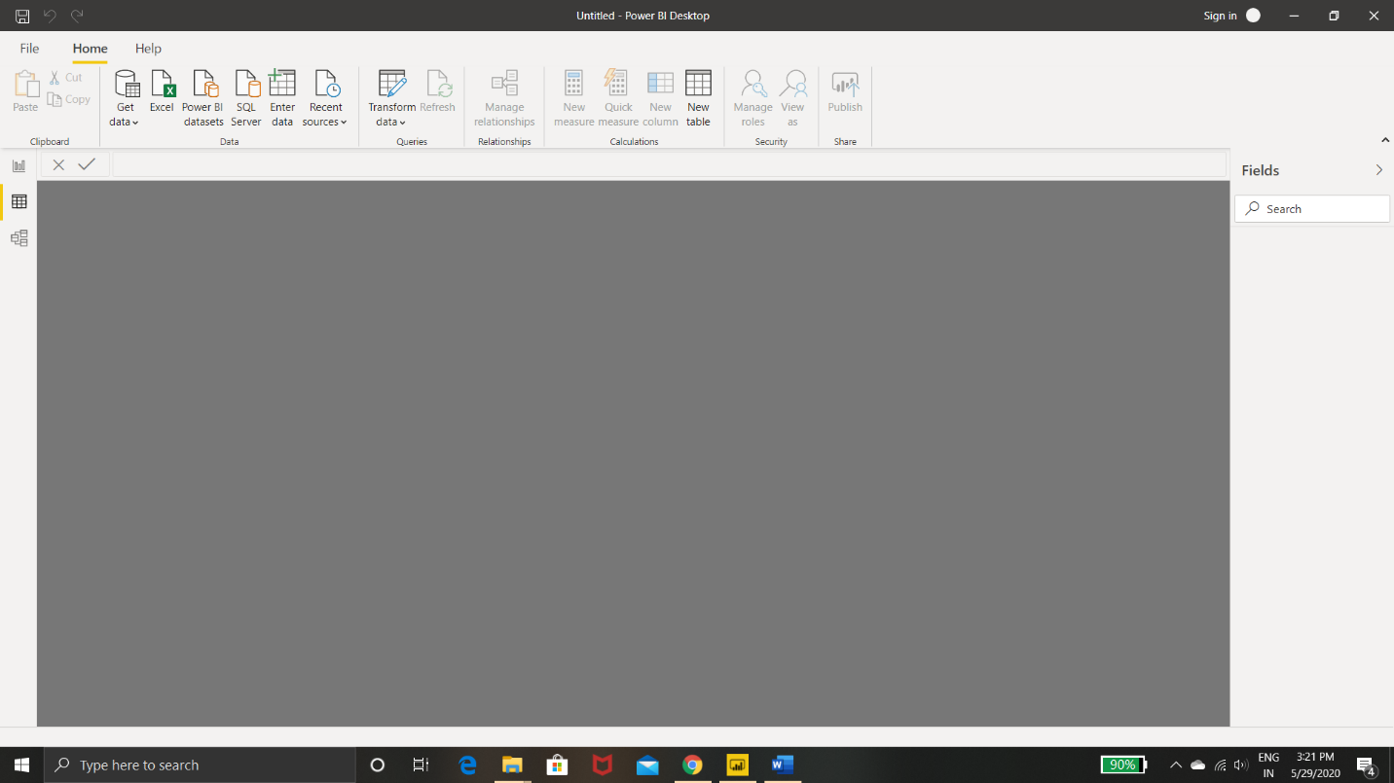

* Model View

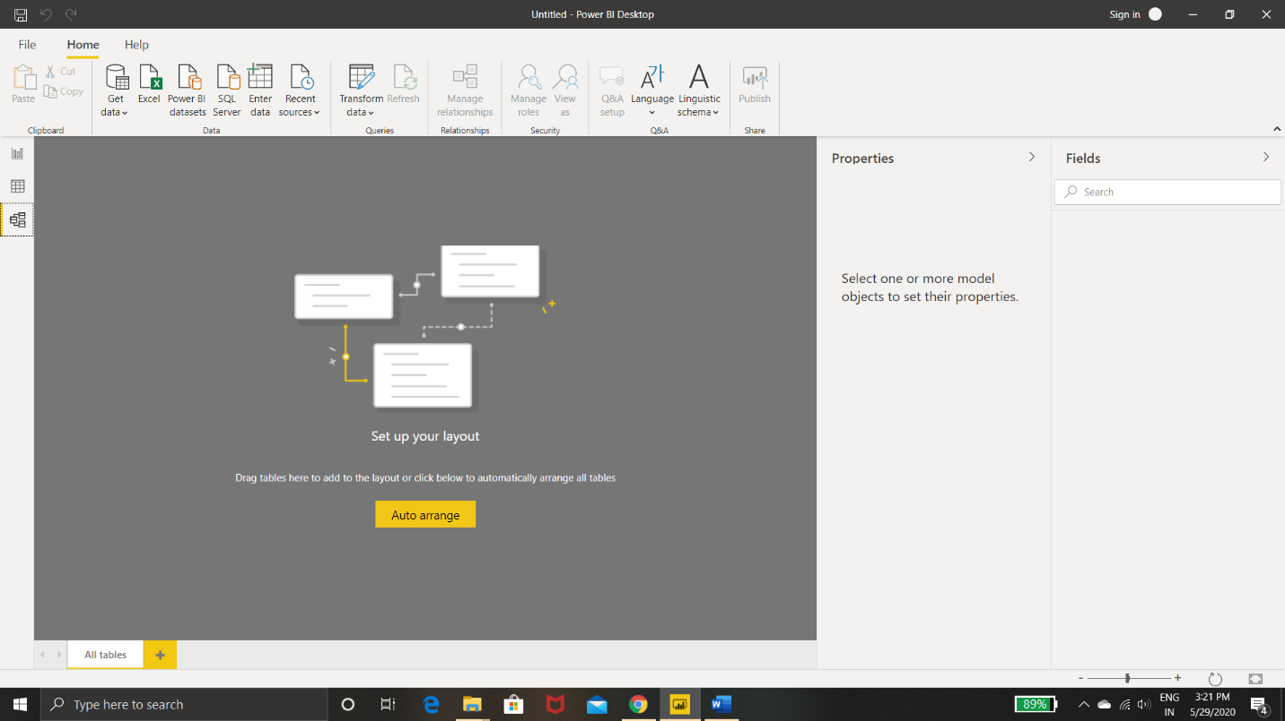

* Power Query Editor

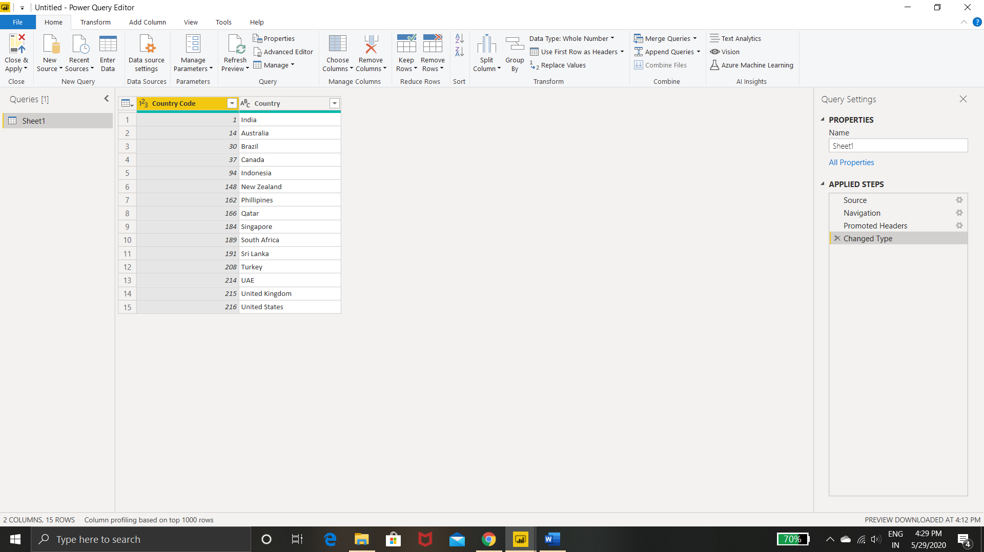

* Advance Editor

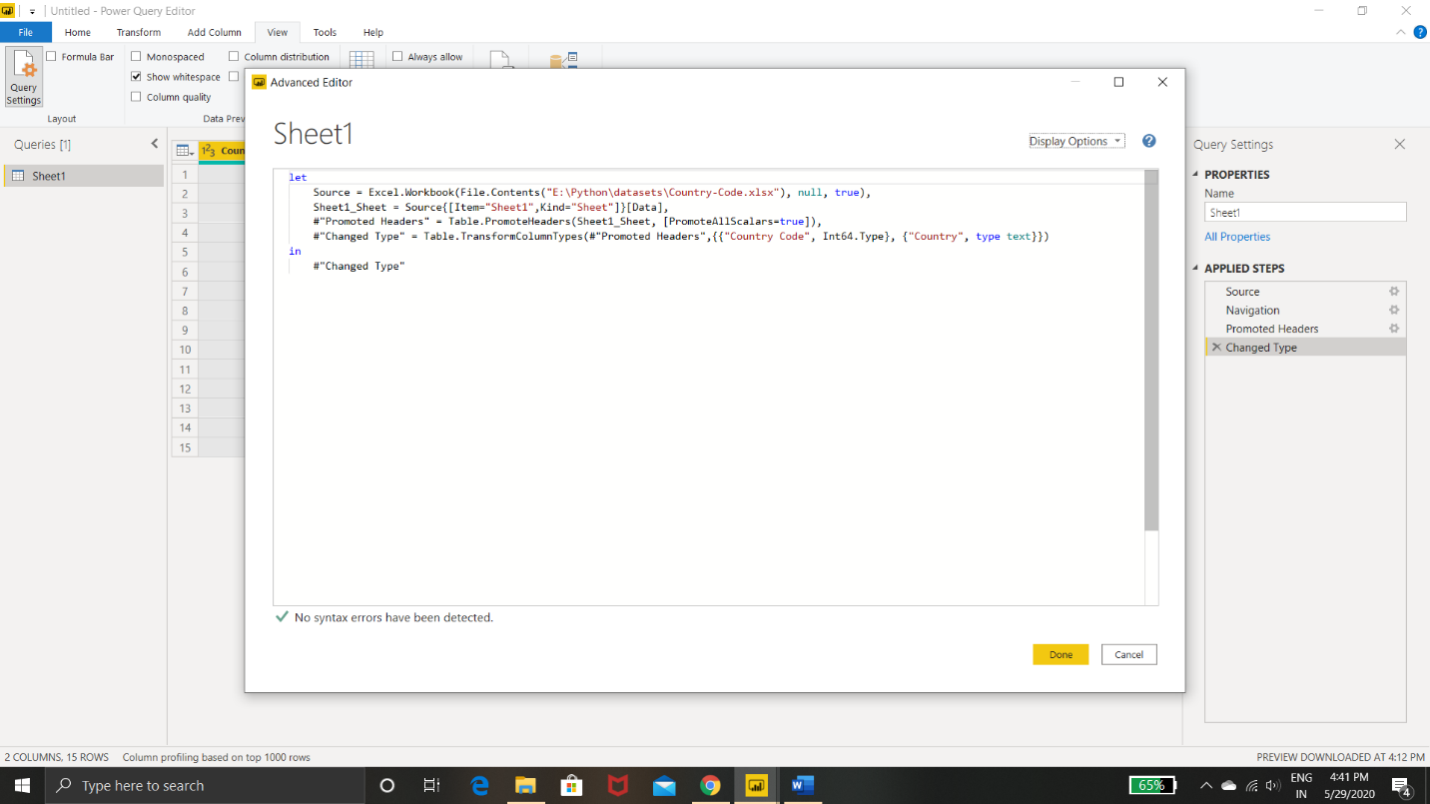

Prepare a document with details of the following along with their price−Power BI Desktop−Power BI Pro−Power BI Premium.

Power BI has three pricing plans:

* Power BI Desktop:

This offering is free to any single user and includes data cleaning and

preparation, custom visualizations and the ability to publish to the Power BI service.

* Power BI Pro:

The Pro plan costs **$9.99**/user/month.

* Power BI Premium :

To publish content to **Premium** capacity, you must also have a **Power**

**BI** Pro license. Therefore, the minimum **cost** of entry is $4,995 (P1) plus $9.99 (Pro) for a total of $5,004.99 per month.